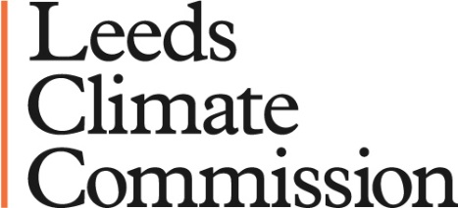

STUDENT PROJECT PROFORMA

Students: Please use this form to submit an expression of interest to carry out a project on behalf of the Leeds Climate Commission

Project proposals should be aligned with the Leeds Climate Commission themes and activities which are outlined in the current Implementation Plan, available on the Leeds Climate Commission website (see downloads here: http://leeds.candocities.org/about-leeds-climate-commission)

Projects are generally not remunerated, but can be a valuable contribution to academic coursework and provide import evidence of practical work experience

Completed forms should be emailed to: leedsclimate@candocities.org

Name of student & contact details:
University
& Course of study:
Academic contact at University:

Proposed project title:

Description of proposed project, outlining what it is about, how it aligns with the work of the Climate Commission:
Proposed outputs of project (e.g. A report, a website, a database etc)
Proposed timescales*:

Any additional relevant information:

*NOTE
Experience from previous projects has indicated that a worthwhile project may take between 6 to 9 months. So a typical overall timeframe will often mean that potential project ideas need to be agreed and refined with the Climate Commission and your host University in the Autumn and Spring so that they can be delivered in the Summer. However this is flexible and can be adapted to suit individual circumstances

